Use-Case Specification: Change password for a user

Version 1.0

Revision History

|  |  |  |  |
| --- | --- | --- | --- |
| **Date** | **Version** | **Description** | **Author** |
| 28/12/201 | 1.0 | Final | Nguyen Khac Phuc |
|  |  |  |  |
|  |  |  |  |
|  |  |  |  |

Table of Contents

1. Change password for a user 4

1.1 Brief Description 4

2. Flow of Events 4

2.1 Basic Flow 4

2.2 Actor 4

3. Special Requirements 4

3.1 Valid input. 4

4. Preconditions 4

5. Postconditions 4

6. Extension Points 5

Use-Case Specification: Change password for a user

# Change password for a user

## Brief Description

This use-case defines the step of changing the password for a specific a user. Admin can change the password of a user or himself in case users forgot their password and need to have a new password for their account.

# Flow of Events

## Basic Flow

* Admin clicks change user password button, then the change user password view appears with id, new password and confirm new password fields. After that, admin enter the id of the user who want to change password, and enter new password and confirm new password fields. Finally, click the submit button. The system will show message change password successfully or failed.

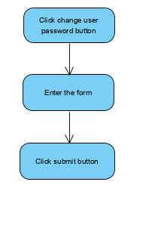

## Actor

-Administrator.

# Special Requirements

## Valid input.

-Admin must enter valid id, new password and confirm password.

# Preconditions

* User must log in into the system with the Admin account

# Postconditions

* Show success message or else show failed message.

# Extension Points